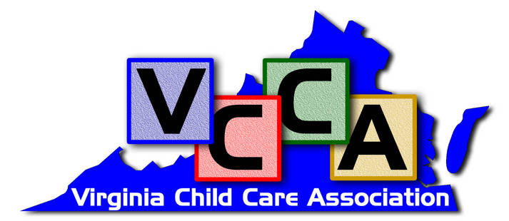

Becoming A Preferred Provider

The Process

First, please provide material explaining the service along with references. If the service is thought to be of interest and benefit to VCCA members, the Membership Committee will vote on the service provider and their products. If accepted as a preferred partner we ask the service provider to:

- Become a member of the association. A $300 annual membership fee is required.
- Provide an added benefit or discount that only members of the VCCA will receive
- Participate in meetings and receptions with your attendance and /or sponsorship
- Provide the association with marketing materials and literature, preferably with the VCCA’s logo on the materials.
- Promote only endorsed products and services at events and in the literature carrying the VCCA name or logo
- Promote membership to the VCCA to potential members
- Support the association with non-dues revenue when possible

The VCCA will provide the member service provider in return with:

- A communication to the membership stating you are our preferred & endorsed provider for the products and/or services agreed upon
- Advertisements in the on-line newsletter
- Advertising on the VCCA web site
- Complimentary advertising in other mailers using stuffers
- Assistance with promoting and selling your products and services
- Suggested contacts or referrals
- Provide display space at some events and/or include marketing pieces in with meeting materials
- A copy of the member list in the format of your choice.

In addition, if either party determines the partnership is not beneficial or not working out at a minimum a 30-day cancellation notice will be given.

Name _____________________________________________ Date _________________

Preferred Partner Signature _____________________________________________________

VCCA Representative _____________________________________ Date _________________
VCCA Signature _________________________________________________

Preferred Partners Information Form:

To better serve you please assist us with some additional information about your business and planned partnership with VCCA.

- What is your primary product line or service you wish VCCA to endorse? ________________________________________________________________________________________________________________________________________________________________________________________________________________________
- Do you serve all of Virginia? If not, what area or region do you serve? ________________________________________________________________________________________________________________________________________________________________________________________________________________________
- Please provide 2 references with contact information: ________________________________________________________________________________________________________________________________________________________________________________________________________________________

- What discounts on what products and services are you willing to offer to only VCCA members? ________________________________________________________________________________________________________________________________________________________________________________________________________________________

- Do you have the ability or plans to do your own marketing to VCCA members other than what VCCA would do for you as a Preferred Partner? If so, what forms or format of marketing?
________________________________________________________________________ ________________________________________________________________________ ________________________________________________________________________

Company: _____________________________________________________

Completed By: _________________________________________________

Phone Number: _________________________________________________

Email: ________________________________________________________

